
Lab Manual- Manage Azure Resources with ARM/BICEP Teamplate

Table of Contents
1 OBJECTIVE 3
2 BICEP Playground 3
3 PRE-REQUISISTE 4
4 Provision Resource with ARM/Bicep with Github 4
4.1 Build the Template with Github – Create Storage Account with Fix Name 4
4.2 Deploy Resource on Azure with Template from Github 7
4.3 Build the Template with Github – Create Storage Account with Resuable Name 8
4.4 Build the Template with Github – Update Storage Account Replication to GRS 11

OBJECTIVE
When deploying Azure resources with an Infrastructure as Code tool, you need to understand what resource types are available, and what values to use in your files
Azure Resource Manager is the deployment and management service for Azure. It provides a management layer that enables you to create, update, and delete resources in your Azure account.
Bicep is a domain-specific language (DSL) that uses declarative syntax to deploy Azure resources similer to ARM . Syntax of Biceps is shorter than ARM. During deployment, the Bicep CLI converts a Bicep file into ARM template JSON.
The following examples show the difference between a Bicep file and the equivalent JSON template. Both examples deploy a SQL Server .
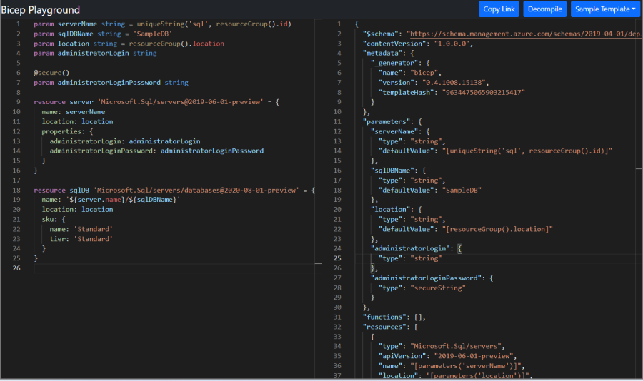

BICEP Playground
The Bicep Playground lets you view Bicep and equivalent JSON side by side. You can compare the implementations of the same infrastructure.
https://bicepdemo.z22.web.core.windows.net/

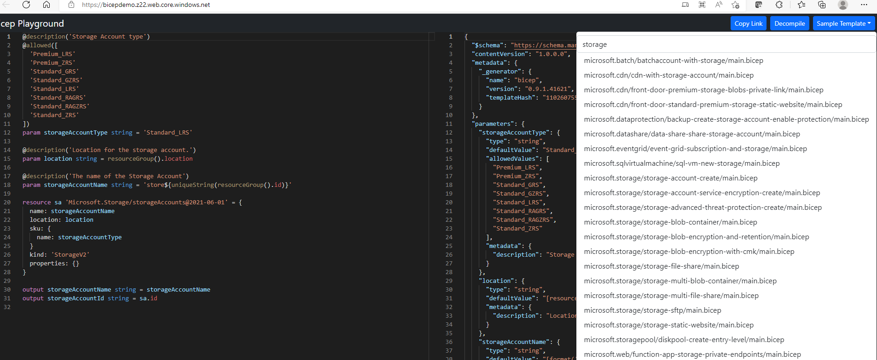

PRE-REQUISISTE
- Accounts in Azure
- A local Computer with 4 CPU, 16 GB RAM, 200 GB disk space

Provision Resource with ARM/Bicep with Github
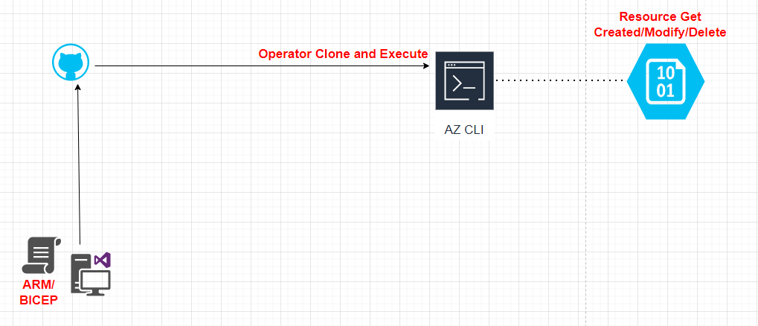

Build the Template with Github – Create Storage Account with Fix Name
- Review the Code Available to github
[You may notice that there's a problem with this template. The storage account name is hard-coded. You can only use this template to deploy the same storage account every time. To deploy a storage account with a different name, you need to create a new template, which obviously isn't a practical way to automate your deployments.}

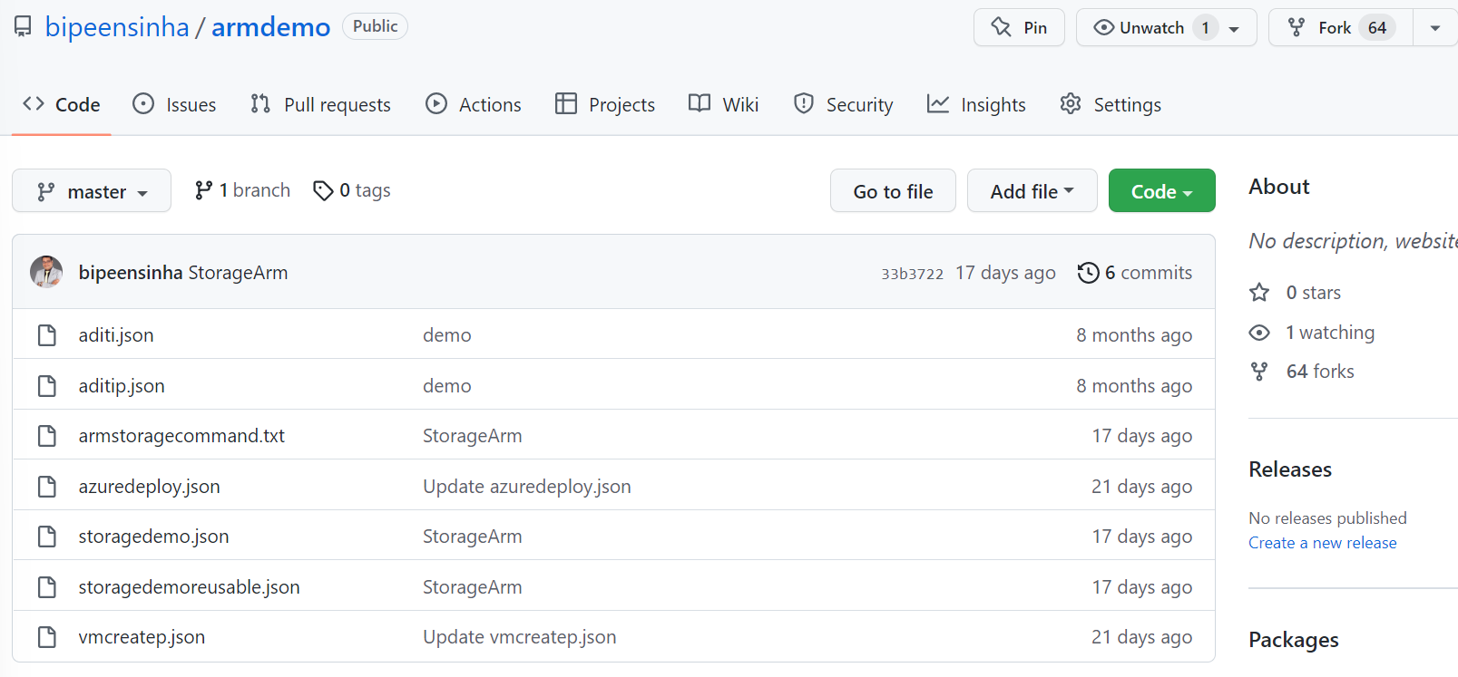
- Click the File Storagedemo.json
- Change the name of storage in File Storagedemo.json ( Add your name as perfix)
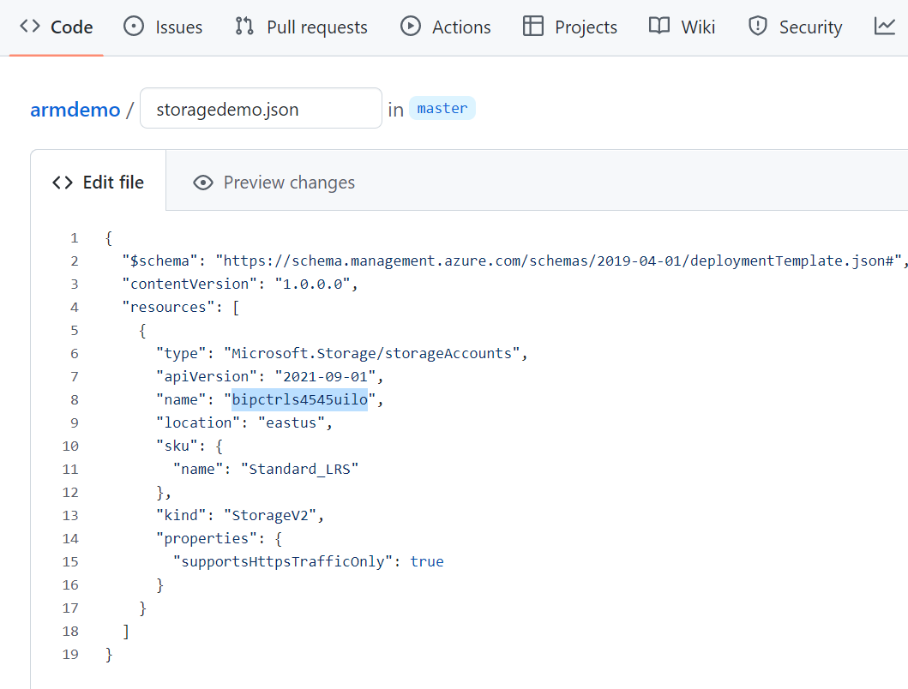
- Commit the Change
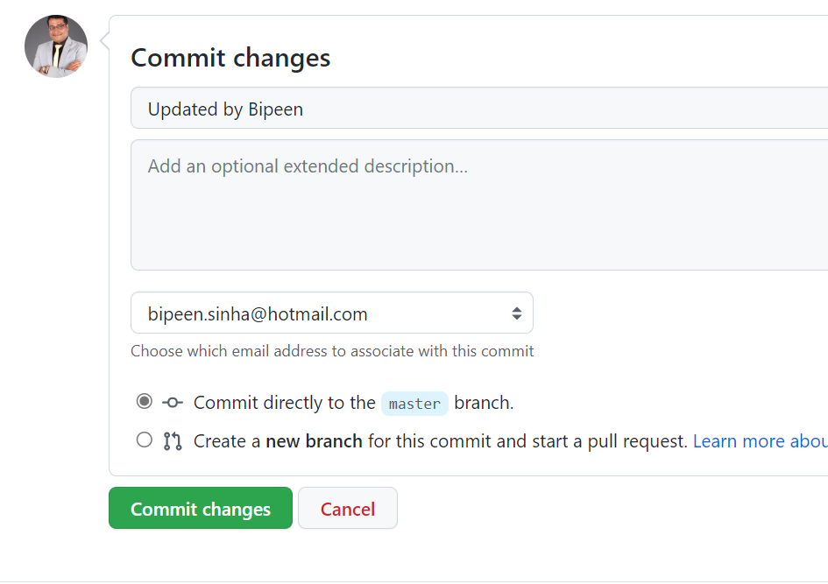

- Copy the URL of Repositiry

Deploy Resource on Azure with Template from Github
- Launch Azure Azure CLI from Azure Poirtal 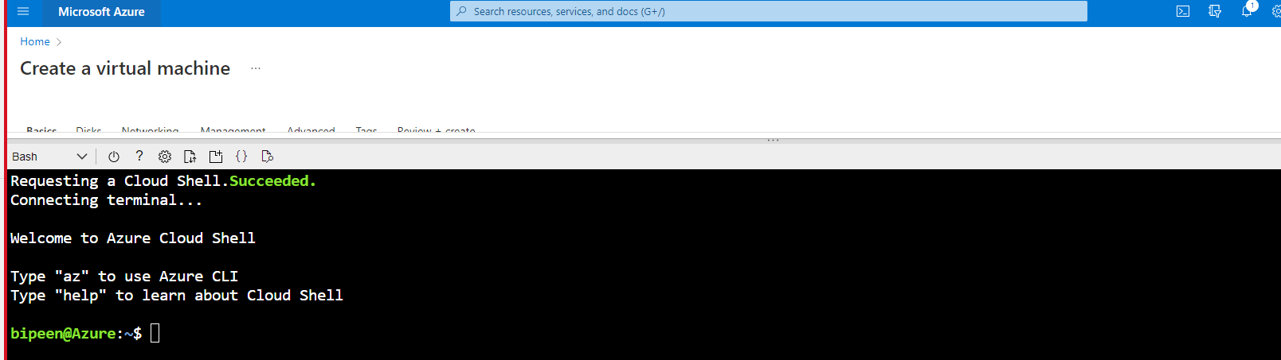
- Clone the Repositiory by typing below command
git clone https://github.com/<URL>
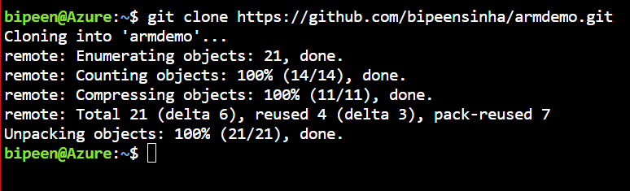
- Go inside the folder armdemo and Type ls to confirm the file
cd armdemo
ls
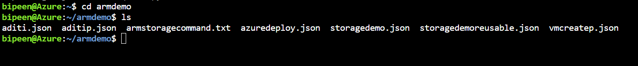
- Launch ARM Script with following command ( Change Resource group as per your availavble group)
az deployment group create --name noparameter --resource-group AZ400RG --template-file storagedemo.json
- Once your Launch is sucessful you should see screen as below
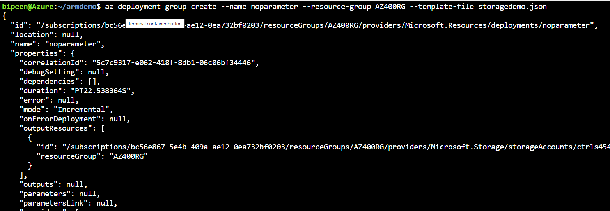
Now validate with Portal
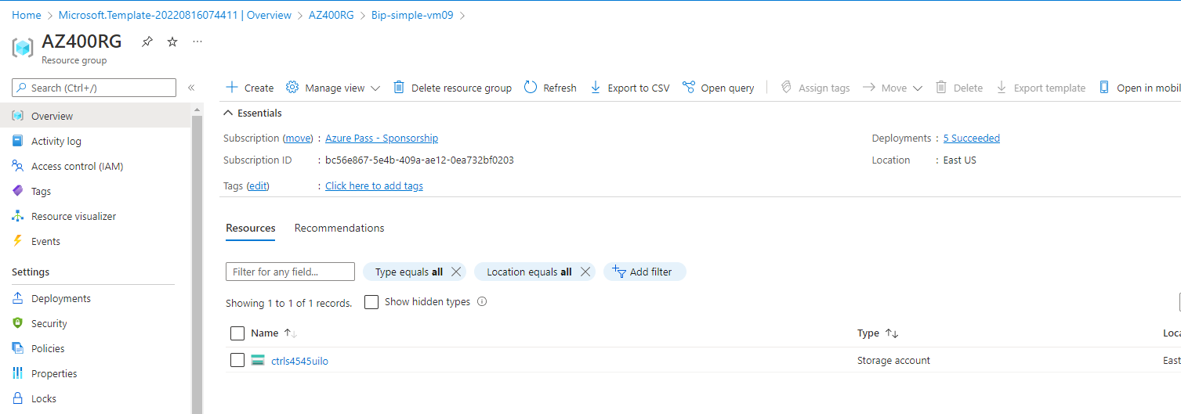

Build the Template with Github – Create Storage Account with Resuable Name
- Review the Code Available to github

To make your template reusable, let's add a parameter that you can use to pass in a storage account name. The highlighted JSON file in the following example shows the changes in your template. The storageName parameter is identified as a string

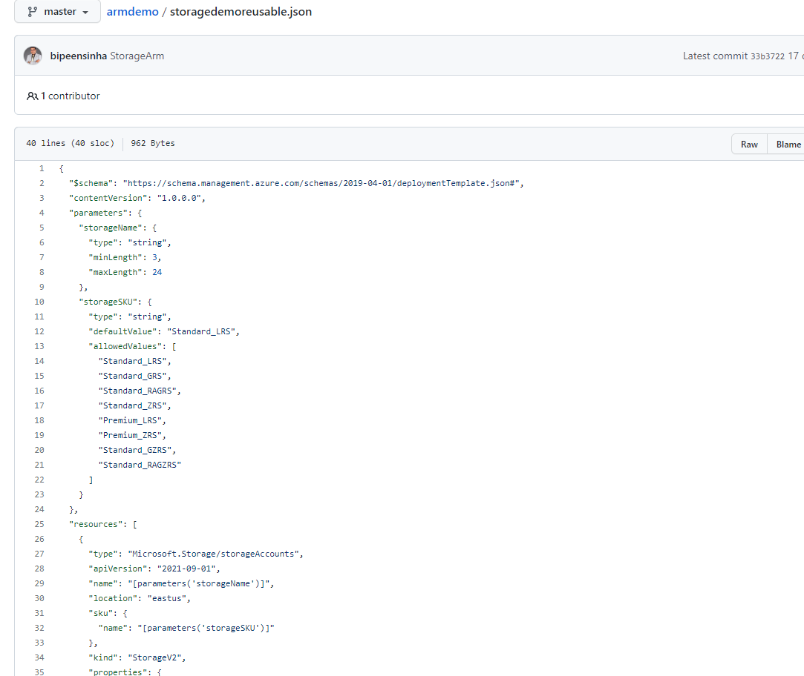

- Let's deploy the template. The following example deploys the template with Azure CLI or PowerShell. Notice that you provide the storage account name as one of the values in the deployment command. Launch the Template in CLI ( Change Azure Resource group Name and New Storage Name)
az deployment group create --name noparameter --resource-group AZ400RG --template-file storagedemoreusable.json --parameters storageName=crtrlstr43sewdr

- Once your Launch is sucessful you should see screen as below

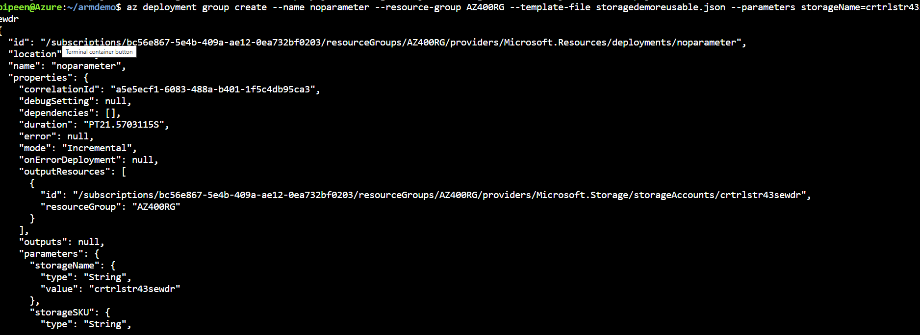
- You can now verify in Portal

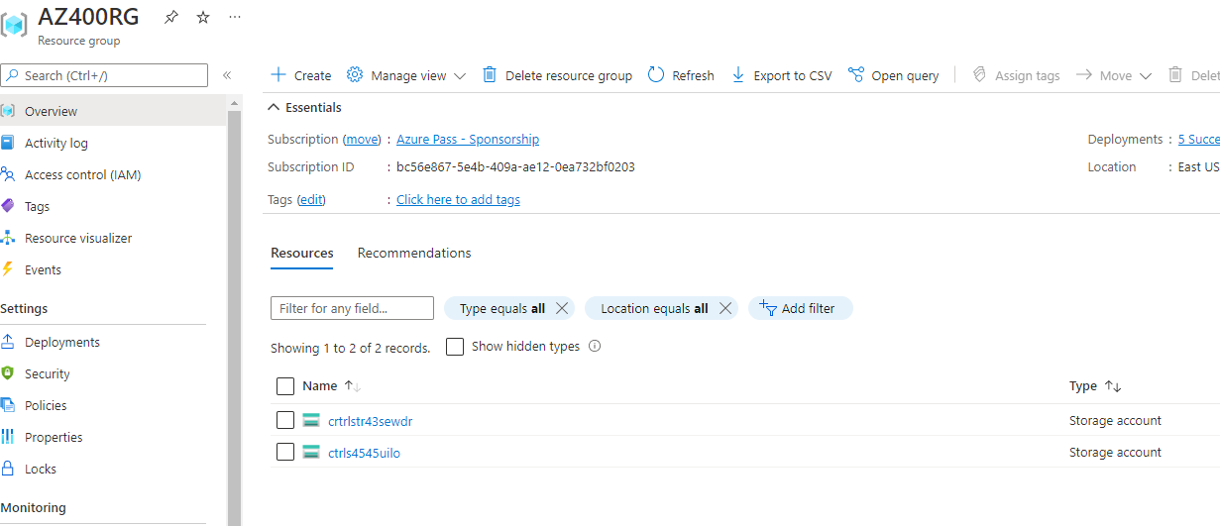

- You should see the Replication as „ Local-reduntant-Storage“
{ In the Next Extercise we are going to update the Existing Storage wioth GRS)

Build the Template with Github – Update Storage Account Replication to GRS

Understand resource updates
After you deploy a storage account with the same name you used earlier, you may wonder how the redeployment affects the resource.
If the resource already exists, and there's no change in the properties, there's no need for further action. If the resource exists and a property changes, it updates. If the resource doesn't exist, it's created.

- Review the Code Available to github

The previous template always deploys a standard locally redundant storage (LRS) Standard_LRS account. You might want the flexibility to deploy different stock keeping units (SKUs) depending on the environment. The following example shows the changes to add a parameter for SKU. Copy the whole file and paste it over your template.
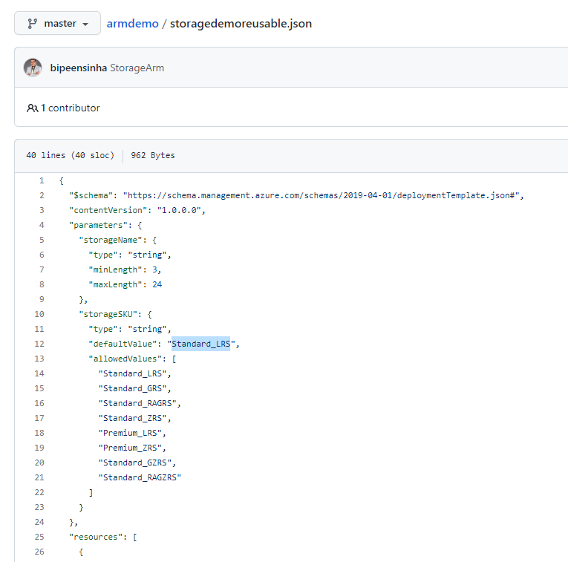
- To see the flexibility of your template, let's deploy it again. This time set the SKU parameter to standard geo-redundant storage (GRS) Standard_GRS
az deployment group create --name noparameter --resource-group AZ400RG --template-file storagedemoreusable.json --parameters storageSKU=Standard_GRS storageName=crtrlstr43sewdr

